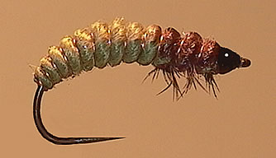

Oliver Edwards Rhyacophila larvae.

This is probably one of Oliver Edwards best know patterns and although there are no Rycophilia caddis flies in SA the pattern works well as a general caddis pattern particularly for Czech nymphing yellowfish. By varying the thickness and colour of the antron yarn a wide variety of shapes and differing caddis larvae can be imitated. The pattern seems complex but this “newer” way of tying it with mono as an additional ribbing makes the process reasonably simple once you get the hang of it.

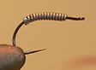 | Take a Grip Caddis hook, and wrap lead wire along the shank to the bend.  Take care to flatten the ends with your thumbnail so as to provide as smooth a transition as possible. This will be made even less noticeable by the addition of thread in the next step.
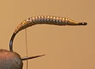 | Wrap 120 denier thread at the eye and then loop around the back of the lead wraps and back to the front. Then wrap the thread tightly over and back to secure the lead tightly on the hook. Build up the thread at either end of the lead to give a smooth transition which will make tying the abdomen much more simple and provide a neater fly.
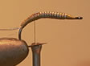 | At the bend tie in: Three strands of antron wool, copper wire and 5 lb nylon monofilament. Keep the profile as smooth as possible. The wool should have been combed out to thin down the first few centimeters. This will provide the natural looking taper of the body.
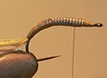 | Take the thread to the front of the hook and twisting the antron yarn into a tight rope wind forward in touching terms to the thorax position.
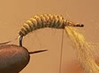 | Temporarily tie off the yarn and thin out the end so as to create a neat taper at the front of the fly in the same manner as at the back. Remove the temporary thread wraps and wind the yarn to the front of the hook. Tie off with the thread.
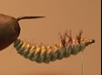 | Next turn the hook upside-down in the vice and wind the monofilament thread between the segments of the body and at the thorax trap in a few fibres of guinea fowl or partridge feathers. At the next segment trap more fibres and repeat at the final segment. Pulling the mono tight should pull the fibres into an “upright position”. Tie off the mono at the eye of the hook.
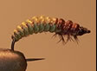 | Finally wind the copper wire through the segments, taking care to avoid trapping the partridge fibres and tie off at the head and form a neat whip finish. Finally colour the thoracic segments with brown waterproof marker pen and add a drop of varnish or glue at the base of the partridge fibres to secure them.

Fly tied by Tim Rolston.

You can find out a lot more about Caddis larvae and other important insects from the book
“Field Guide to Insects of South Africa” by Picker, Griffiths and Weaving.
Available from Netbooks at www.netbooks.co.za

