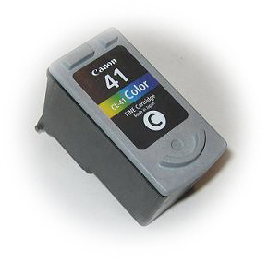

Canon Cartridge
PG-41 (#41)

Refill Instructions for Color cartridge

Instructions
1. Put the cartridge on some paper towels in an area where you can tolerate a spill.
2. Peal off the top label.
3. You will notice three small holes (too small for a syringe needle to get into). Drill each hole larger with a thumb drill.
4. Fill the syringe with 6 ml. of color ink.
5. Very S-L-O-W-L-Y inject ink into each chamber until the sponge full
6. When finished, replace the top label or leave it off (it will make no difference in the printing).

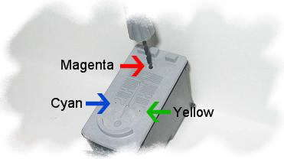
7. Replace the cartridge and run 1 - 3 cleaning cycles as per printer instructions.
Or print the following page:
http://www.refillinstructions.com/color.htm
If necessary leave cartridge in printer for up to 24 hours. (Allows ink to flow to the print head).

Note: Each time the cartridge is removed from the printer an "empty cartridge" message appears and a blinking amber light will come on, on the printer. Holding the paper feed button down for 3-5 sec. will allow you to override the counter.

A Refill Kit should include Ink plus the following:

Thumb Drill
Three 10cc Syringes with sharp needle

